Carbon footprint

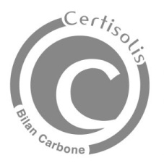

**Certisolis** is the only certification body for photovoltaic products to carry out the "Simplified Carbon Assessment" required in calls for tenders from the Energy Regulatory Commission (CRE) for solar power plants.

It is now mandatory to use an ISO 17065 accredited certification body to issue the carbon assessment certificates required in the specifications for CRE calls for tenders relating to the construction and operation of electricity production.

Tongwei – covered for 44 and 46 Shingled Modules- Only manufacturer brand in UK with certified Carbon Footprint . Performance not comparative but better than global average. As vertically integrated company have assurance of accuracy and testing from ingot to panel to installation.